Longwell Green SPORTS Junior FC
Formed 1966
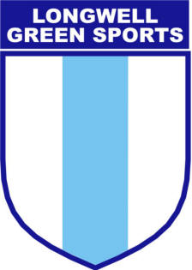

Respect Code of Conduct for Players
We all have a responsibility to promote high standards of behaviour in the game.
As a player, you have a big part to play. That’s why Longwell Green Sports Junior Football Club supports the FA’s Respect Code of Conduct and is asking every player
to follow this.

Play your part and support The FA’s Code of Respect. This means that when playing football, I will:

- Always play my best for the benefit of the team
- Encourage and respect my team mates
- Play fairly and be friendly
- Not use inappropriate language
- Play by the rules and respect the Referee, other team and my coach/manager
- Shake hands at the end of the game with the referee and other team - win or lose
- Listen carefully to what my coach tells me
- Understand that a coach has to do what’s best for the team
- Talk to someone I trust or the club welfare officer if I’m unhappy about anything at my club
- Respect the facilities home & away

I understand that if I do not follow the Code, I may:

• Be asked to apologise to whoever I’ve upset
• Receive a formal warning
• Be dropped, substituted or suspended from training

